# Laboratory 8

Title of the Laboratory Exercise: Stored Procedure in MySQL

1. Introduction and Purpose of Experiment

A stored Procedure is a procedure stored in a database which can be called by the database engine and connected programming languages. A stored procedure is invoked using the CALL statement. A procedure has a name, a parameter list, and SQL statement(s). The parameters make the stored procedure more flexible and useful. In MySQL, a parameter has one of three modes: IN, OUT, or INOUT. By doing this lab, students will be able to implement MySQL stored procedure.

1. Aim and Objectives

Aim

* To implement MySQL stored procedure

Objectives

At the end of this lab, the student will be able to

* Design SQL procedures for the given problem statement
* Implement the procedures in MySQL

1. Experimental Procedure
   * 1. Analyse the problem statement
     2. Create the table and its attributes with essential properties
     3. Design the procedures in MySQL
     4. Implement the procedures in MySQL
     5. Test the implemented procedures
     6. Document the Results
     7. Analyse and discuss the outcomes of your experiment
2. Questions
   1. Design and implement a procedure which accepts one INOUT parameter (count) and one IN parameter (inc). Inside the stored procedure, increase the counter (count) by the value of the inc parameter.
   2. Create a table OFFICES in OFFICEDB with attributes such as OfficeCode, Name, City, Country, and Phone.
      1. Write a ‘GetPhoneNo’ procedure in MySQL to take the name of a person as an input and display the phone number of that person.
      2. Write a ‘GetOffice’ procedure in MySQL to take the name of a country as an input and display the number of offices located in a particular Country.
3. **Presentation of Results**

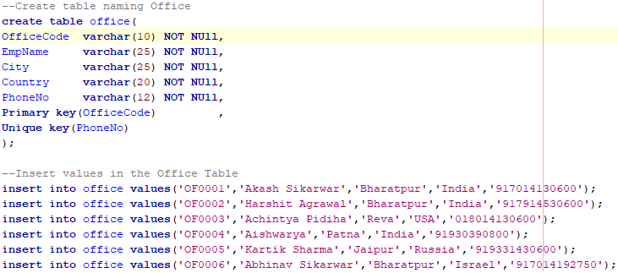

Figure 1 Create table and Insert values

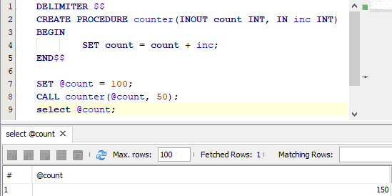

Figure 2 Procedure for counter and Calling the Procedure



Figure 3 Result of the counter procedure call

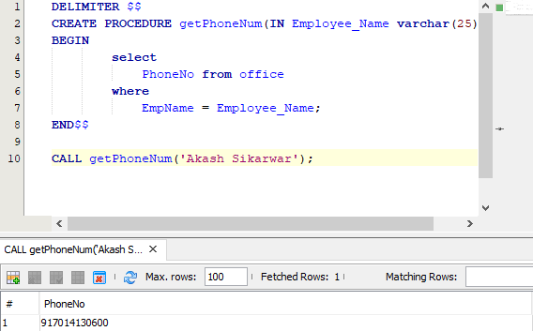

Figure 4 Procedure Call to get Phone Number



Figure 5 Result of the getPhoneNo procedure call

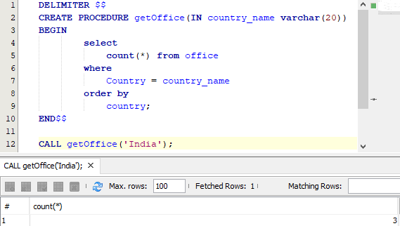

Figure 6 Procedure call to count number of offices in a particular country



Figure 7 Result of getOffice procedure call with Argument "India"

1. **Conclusions**

In MySQL, a parameter has one of three modes: IN, OUT, or INOUT.

* IN is the default mode. When you define an IN parameter in a stored procedure, the calling program has to pass an argument to the stored procedure. The value of an IN parameter is protected. It means that even the value of the IN parameter is changed inside the stored procedure, its original value is retained after the stored procedure ends. In other words, the stored procedure only works on the copy of the IN parameter.
* The value of an OUT parameter can be changed inside the stored procedure and its new value is passed back to the calling program. Notice that the stored procedure cannot access the initial value of the OUT parameter when it starts.
* An INOUT parameter is a combination of IN and OUT parameters. It means that the calling program may pass the argument, and the stored procedure can modify the INOUT parameter, and pass the new value back to the calling program.

1. **Comments**

**1. Limitations of Experiments**

* It’s difficult to debug stored procedures. Unfortunately, MySQL does not provide any facilities to debug stored procedures like other enterprise database products such as Oracle and SQL Server.
* Developing and maintaining stored procedures often requires a specialized skill set that not all application developers possess. This may lead to problems in both application development and maintenance.

1. **Recommendations**

Stored procedures help reduce the network traffic between applications and MySQL Server. Because instead of sending multiple lengthy SQL statements, applications have to send only the name and parameters of stored procedures.